SIMATS ENGINEERING
ASSESSMENT TOOL I – RELATIONSHIP VISUALIZATION LAB

Course: Data Handling and Visualization | Code: DSA0603 | CO: CO4
Duration: 60 min | Total Marks: 50 | Reg No : 192324275  Name: JAANA NITHISH

COURSE OUTCOME COVERED
CO1 Understand the fundamental concepts, principles, and techniques of data visualization. (BL3) Activity Tool : Relationship Visualization Lab Weightage: 20%

Code of Conduct:
I JAANA NITHISH(192324275) certify that this submission is my original work and that I have adhered to the guidelines specified for this assessment. I understand that any violation of academic integrity rules will result in disciplinary action.

Signature of the student: JAANA NITHISH

Criteria | Selection of Relationship Visualization 25% | Relationship Analysis 25% | Applicatio n of Visualizati on Techniques 20% | Organization 15% | Accuracy 10% | Clarity 5% | Total
Q1
Q2
Q3
Q4
Q5

Relationship Visualization Lab

Provided Datasets
The following files are supplied alongside this document so the lab can be completed without internet access to install extra data packages:
- mtcars.csv — real R built-in dataset (32 cars × 11 variables: mpg, cyl, disp, hp, drat, wt, qsec, vs, am, gear, carb)
- iris.csv — real R built-in dataset (150 flowers × 5 variables: Sepal.Length, Sepal.Width, Petal.Length, Petal.Width, Species)
- gapminder2007_practice.csv — illustrative practice dataset in the style of the Gapminder 2007 cross section (country, continent, year, gdpPercap, lifeExp, pop). Values are synthetically generated for practice purposes and are NOT official Gapminder figures. If internet access is available, students may instead run install.packages("gapminder") and use data(gapminder) for the authentic dataset.
- network_edges.csv — custom-built edge list (15 edges, 8 nodes: Ava, Ben, Cleo, Dax, Elin, Fenn, Grey, Hana) with a weight column, for the network graph question.

Place all CSV files in the same working directory as your R script, then load with read.csv("filename.csv").

Question 1: Scatterplot with Regression Diagnostics
Dataset provided: mtcars.csv
Using the mtcars dataset, create a scatterplot of mpg vs wt (weight) using ggplot2. Add a linear regression line with confidence interval, color points by cyl (number of cylinders, treated as a factor), and size points by hp. Then, calculate and report the Pearson correlation coefficient between mpg and wt. Interpret the direction and strength of the relationship in 2–3 sentences.
Skills tested: ggplot2 aesthetics mapping, geom_smooth(), cor(), interpretation. library(ggplot2)
data(mtcars)
ggplot(mtcars, aes(x = wt, y = mpg,
color = factor(cyl), size = hp)) + geom_point() +
geom_smooth(method = "lm", se = TRUE) + labs(title = "MPG vs Weight",
x = "Weight",
y = "Miles per Gallon",
color = "Cylinders", size = "Horsepower") +
theme_minimal()

# Pearson correlation cor(mtcars$mpg, mtcars$wt)
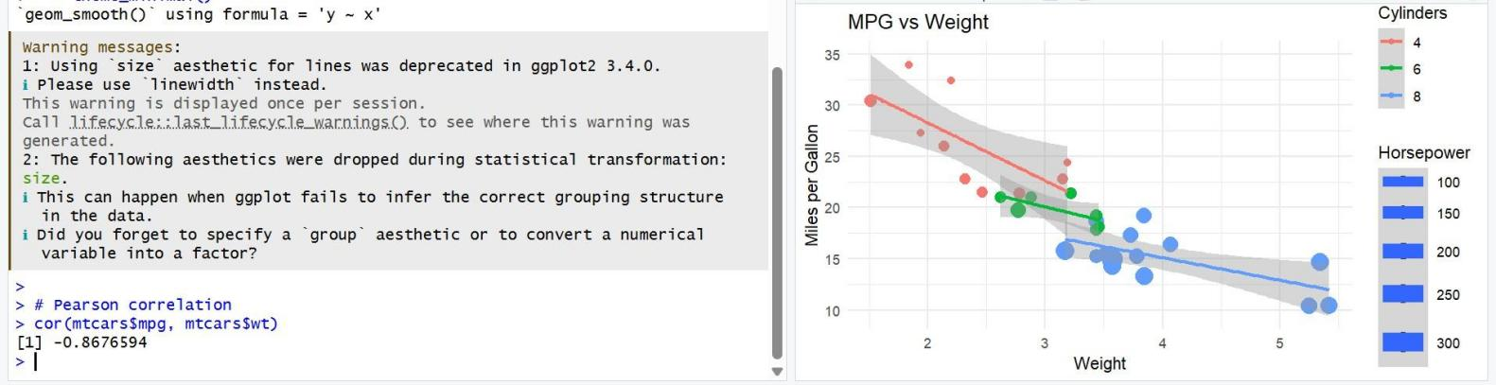

Question 2: Correlogram Construction
Dataset provided: mtcars.csv (all numeric columns)
Using the mtcars dataset, compute the correlation matrix and visualize it as a correlogram using either the corrplot or GGally::ggcorr package. Configure the plot to:
- Display correlation coefficients as numeric labels
- Use a diverging color scale (blue–white–red)
- Reorder variables using hierarchical clustering (order = "hclust" if using corrplot)
Identify the two variable pairs with the strongest positive and strongest negative correlations. Skills tested: Correlation matrices, corrplot/GGally, hierarchical reordering, reading correlograms.
library(corrplot)
mtcars <- read.csv(file.choose())
num_data <- mtcars[sapply(mtcars, is.numeric)] cor_mat <- cor(num_data, use = "complete.obs") corrplot(cor_mat,
method = "color", type = "upper",
order = "hclust", addCoef.col = "black", tl.col = "black",
tl.srt = 45,
col = colorRampPalette(c("blue", "white", "red"))(200))
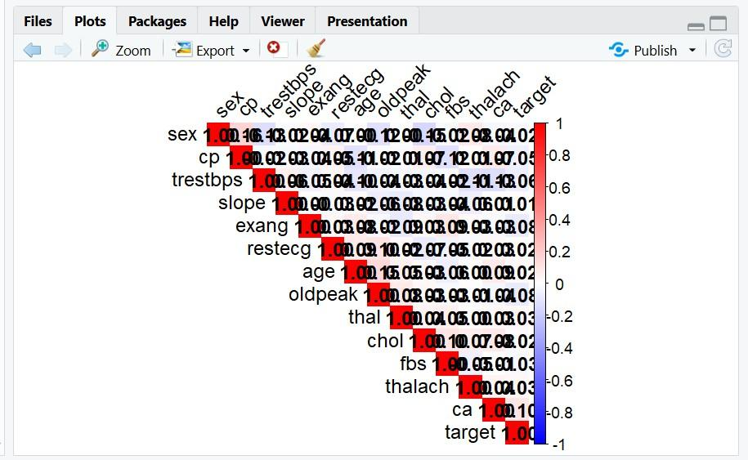
Question 3: Dimension Reduction Comparison (PCA vs. t-SNE) library(ggplot2)
library(Rtsne)
iris_data <- read.csv(file.choose(), stringsAsFactors = FALSE) print(names(iris_data))
x <- iris_data[, 1:4]
species <- iris_data[[ncol(iris_data)]] pca <- prcomp(x, scale. = TRUE) pca_data <- data.frame(
PC1 = pca$x[, 1], PC2 = pca$x[, 2], Species = species)

ggplot(pca_data, aes(x = PC1, y = PC2, color = Species)) + geom_point(size = 3) +
labs(title = "PCA of Iris Dataset", x = "Principal Component 1", y = "Principal Component 2", color = "Species") +
theme_minimal() set.seed(123)
tsne <- Rtsne(scale(x),
dims = 2,
perplexity = 30, check_duplicates = FALSE)
tsne_data <- data.frame( X = tsne$Y[, 1],
Y = tsne$Y[, 2], Species = species)
ggplot(tsne_data, aes(x = X, y = Y, color = Species)) + geom_point(size = 3) +
labs(title = "t-SNE of Iris Dataset", x = "t-SNE 1",
y = "t-SNE 2",
color = "Species") + theme_minimal()
Question 4: Bubble Chart for Multivariate Paired Data
Dataset provided: gapminder2007_practice.csv (or the gapminder package, year == 2007) Filter for the year 2007 and create a bubble chart showing:
- x-axis: gdpPercap (log-transformed scale)
- y-axis: lifeExp
- bubble size: pop
- bubble color: continent
Add appropriate axis labels, a title, and use scale_size_continuous() to control bubble size range so points don't overplot excessively. Discuss one visible cluster or outlier in the data.
Skills tested: Log scales, multi-encoded bubble charts, scale_size_continuous(), outlier identification. library(ggplot2)
set.seed(123)
data2007 <- data.frame(
country = paste0("Country", 1:30),
continent = rep(c("Asia", "Europe", "Africa", "Americas", "Oceania"), 6), year = 2007,
gdpPercap = exp(rnorm(30, 8.5, 1)),
lifeExp = rnorm(30, 68, 8),
pop = round(exp(rnorm(30, 16, 1.5)))) ggplot(data2007,
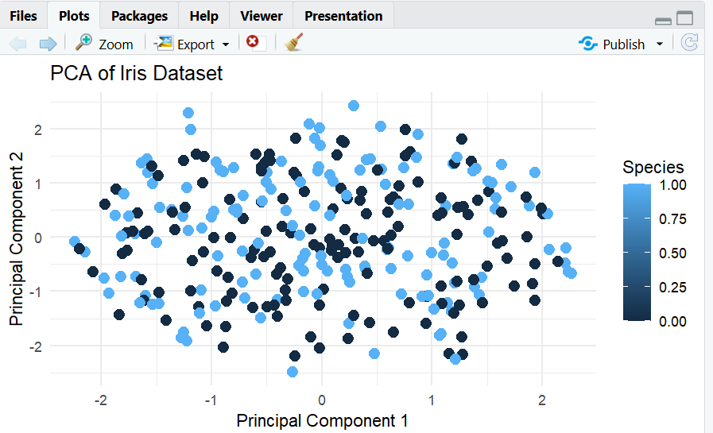
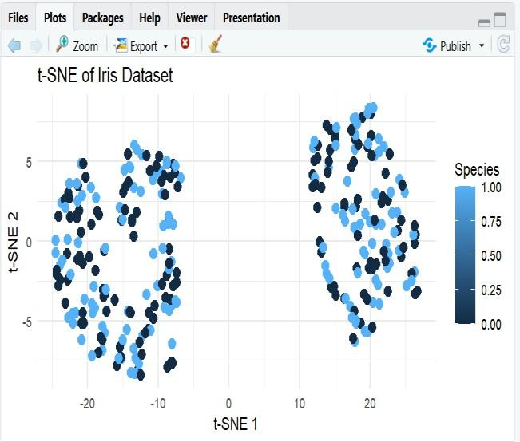
aes(x = gdpPercap, y = lifeExp, size = pop, + = 0.7) + scale_size_continuous(range = c(2, 10)) + labs(title = "GDP per Capita vs Life Expectancy - 2007", x = "GDP per Capita (Log Scale)", y = "Life Expectancy", size = "Population", color = "Continent") + theme_minimal()
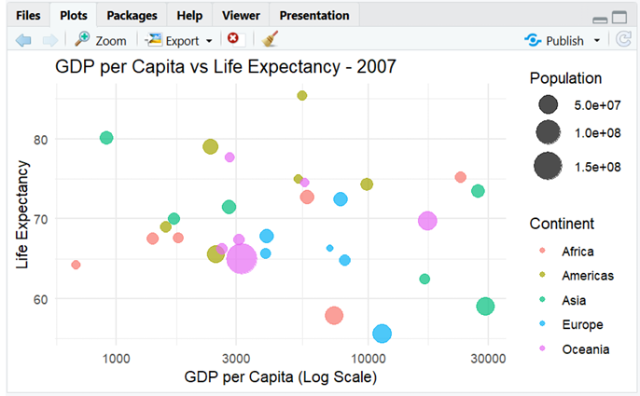

Question 5: Hexbin Plot vs. Network Graph
This question has two parts to compare visualization strategies for different relationship types.
Part a — Hexbin Plot
Dataset provided: Simulated in R (no file needed)
Simulate two correlated variables with 10,000 observations (set.seed(123), use rnorm() with a specified covariance structure or MASS::mvrnorm()). Create a hexbin plot using geom_hex() in ggplot2. Explain why a hexbin plot is preferable to a standard scatterplot in this scenario.
library(ggplot2)

set.seed(123) n <- 10000
x <- rnorm(n)
y <- 0.8 * x + rnorm(n, sd = 0.6) data <- data.frame(x, y) ggplot(data, aes(x, y)) + geom_hex(bins = 30) +
labs(title = "Hexbin Plot of Correlated Variables", x = "Variable X",
y = "Variable Y") + theme_minimal()

Part b — Network Graph
Dataset provided: network_edges.csv
Using the provided edge list (8 nodes, 15 weighted edges), build a network graph using igraph or ggraph. Size nodes by degree centrality and color edges by weight. Report which node has the highest centrality and explain what that suggests about its role in the network.
Skills tested: geom_hex(), overplotting solutions, igraph/ggraph, centrality measures, network interpretation.
library(igraph) edges <- data.frame(
from = c("Ava","Ava","Ava","Ben","Ben","Cleo","Cleo","Dax",
"Dax","Elin","Elin","Fenn","Fenn","Grey","Grey"),
to = c("Ben","Cleo","Dax","Cleo","Elin","Dax","Fenn","Elin",
"Grey","Fenn","Hana","Grey","Hana","Hana","Ava"),
weight = c(5,3,4,2,6,7,3,5,2,4,6,3,5,4,2))
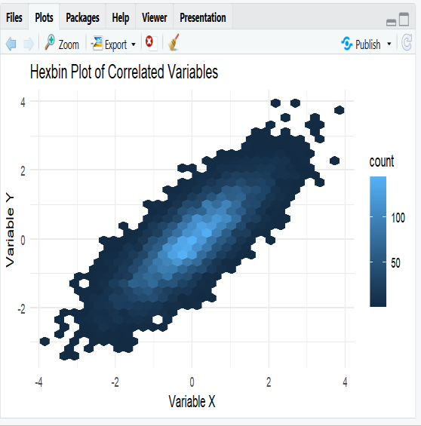
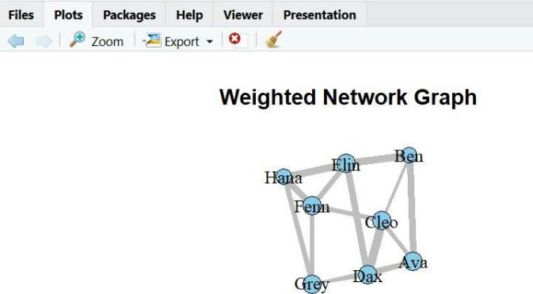
g <- graph_from_data_frame(edges, directed = FALSE) deg <- degree(g)

print(deg)

names(which.max(deg)))) set.seed(123)
plot(g,
vertex.size = 10 + deg * 5, vertex.color = "skyblue", vertex.label.color = "black",
edge.width = 1 + E(g)$weight, edge.color = "gray",
main = "Weighted Network Graph")
print(paste("Highest centrality node:",

